Installing _ADMIN user for Exchequer SQL rounding functions

1. Ensure OLE Automation is enabled
Open the SQL Server Surface Area Configuration utility from the Windows ‘Programs’ menu:
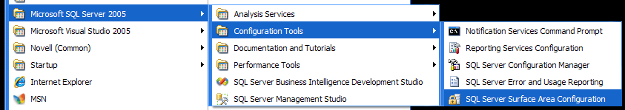

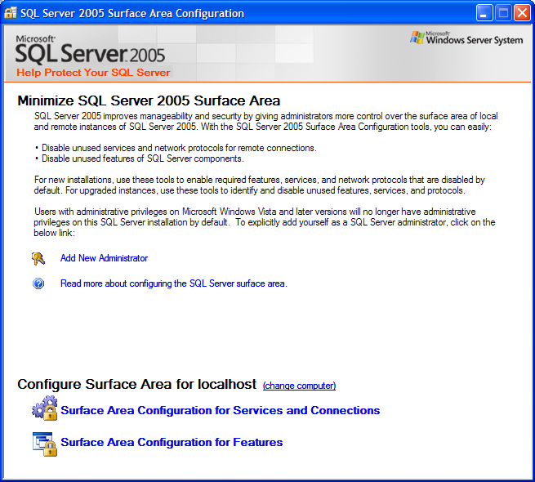
Click Surface Area Configuration for Features:

Select the correct database from the tree, and then select the OLE Automation entry, and make sure that Enable OLE Automation is ticked:
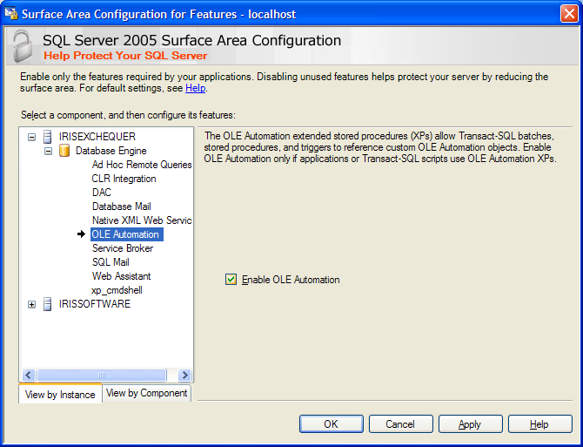

2. Install Exchequer SQL

3. Add Admin user to Master database.
Launch SQL Server Management Studio, and connect to the server.
Open the Databases tree, down to the Users for the master database. Right-click on Users and select ‘New User...’
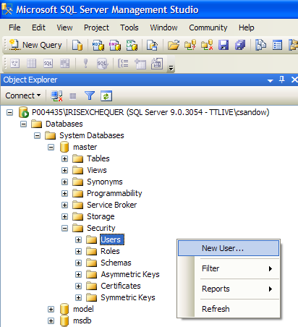

Enter the database name that your Exchequer install is using, adding ‘_ADMIN’ to the end, as the User name and Login name:
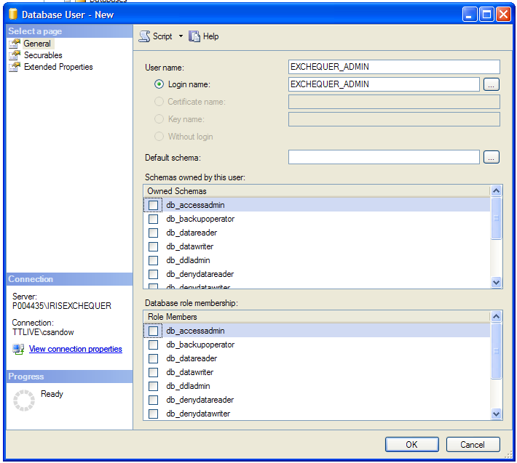
‘Ok’ this dialog.

4. Add user permissions
Select the ‘master’ database, and click ‘New query’
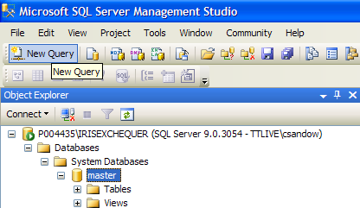

Add the following lines into the edit window, specifying the correct user name
Grant Execute on sys.sp_OACreate to Exchequer_Admin
Grant Execute on sys.sp_OAMethod to Exchequer_Admin
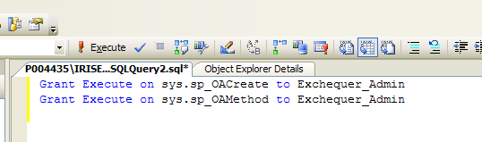
Click the Execute button to run these.

